**VISVESVARAYA TECHNOLOGICAL UNIVERSITY**

**Jnana Sangama, Belgavi – 590014.**



**MINI PROJECT REPORT**

**ON**

**“FORBES INFORMATION”**

Submitted in partial fulfillment for the requirement of V semester for the

**Degree of Bachelor of Engineering in**

**COMPUTER SCIENCE & ENGINEERING**

For the academic year 2017-2018

**SUBMITTED BY:**

RAJEEV RANJAN

**(V** Semester**)**

**Under the guidance of:**

MRS. MANJULA K

**Assistance Professor,**

**Department of CSE**



**DON BOSCO INSTITUE OF TECHNOLOGY, BENGALURU-74**

**DON BOSCO INSTITUTE OF TECHNOLOGY**

**Kumbalagodu, Bengaluru-560074**



**DEPARTMNET OF COMPUTER SCIENCE AND ENGINEERING**

CERTIFICATE

This is to certify that the Project Report entitled **“FORBES INFORMATION”**

is a bonafide Project work carried out by **RAJEEV RANJAN(1DB15CS120)**, in partial fulfillment of V semester for the Degree of **Bachelor of Engineering in Computer Science and Engineering** of Visvesvarayya Technological University, Belgavi, during the academic year 2017-2018. It is certified that all corrections/suggestions indicated for Internal Assessments have been incorporated with the degree mentioned.

**Project Guide Head of Department**

**MRS. MANJULA K Prof. B.S Umashankar**

Ass.Prof,Dept of CSE, Head of Department

Dept,of CSE, Dept, of CSE,

DBIT,Banglore. DBIT,Banglore.

**External Viva**

**Name of the Examiners Signature with Date**

1._________________ _________________

2._________________ _________________

**DON BOSCO INSTITUE OF TECHNOLOGY**

**Kumbalgodu, Bengaluru -560074.**



**DECLARATION**

I, **RAJEEV RANJAN**, student of fifth semester B.E, Department of Computer Science and Engineering, Don Bosco Institute of Technology, Kumbalagodu,Bengaluru, declare,delete that the Project Work entitled **“FORBES INFORMATION”** has been carried out by and submitted in partial fulfillment of the requirement of V semsester Feb 2017-June 2018. The matter embodied in this report has been submitted to any university or institute for the award of any other degree or diploma.

**Place:** Bengaluru **Rajeev Ranjan**

**Date: (1DB15CS120)**

**ACKNOWLEDGEMENT**

At the various stages in doing the mini project, a number of people have given me invaluable

comment on the manuscript. I take this opportunity to express my deepest gratitude and

appreciation to all those who helped me directly or indirectly towards the successful completion

of this project.

I would like to thank Principal, Don Bosco Institute of Technology for his support though out

this project.

I express my wholehearted gratitude to Prof. B.S.UMASHANKAR, Prof. & Head of

Department of CSE, who is our respectable Head of Dept of Computer Science.I wish to

acknowledge for his valuable help and encouragement.

In this regard I owe a heartfelt gratitude to my guide Professors of Department of Computer

Science and Engineering, for her timely advice on the project and regular assistance throughout

the project work. I would also like to thank the staff members of Department of Computer

Science and Engineering for their corporation.

**ABSTRACT**

The main aim and objective was to plan and program system application .We have to apply

the best software engineering practice for system application. I developed a

“FORBES INFORMATION” using Java and Oracle.

The “FORBES INFORMATION” is an American business magazine, published bi-weekly, it features original articles on finance, industry, investing, and marketing topics. Its headquarters is located in Jersey City, New Jersey

The magazine is well known for its lists and ranking, including of richest Americans (THE FORBES 400), of the world’s top companies (THE FORBES GLOBAL 2000), and THE WORLD’S BILLIONAIRES. The motto of forbes magazine is ”THE CAPITALIST TOOL”. It’s chairman and editor-in-chief is Steve Forbes, and its CEO is Mike Perlis.

**CONTENTS**

1. **Introduction** 7
2. **Project Analysis** 10
3. **Schema Diagram** 12
4. **E-R Diagram** 13
5. **Data Tables** 14
6. **Snap Shots** 16
7. **Conclusion** 28
8. **Reference Book** 29

**1.INTRODUCTION**

I have developed, the FORBES INFORMATION to shows the list and ranking of world most Richest people across the world and their total Capitalist World Wide across the globe.

The Richest Person list is started by Malcolm Forbes in 1982 and the list is published annually around September. The Forbes had more Wealth combined than the bottom 64% of U.S. population, about 204 Million people.

* 1. **Aim**

The main aim of Forbes information is to provide the list of Inherited Wealth and explain why many Americans who have become rich may have had a” substantial head start”. This shows the wealth of top most richest peoples.

* 1. **Objective**

The main objective was to create a unique and useful “FORBES INFORMATION” To provide the right information from the forbes magazine.

* 1. **Scope:**

FORBES information application is as follows:-

* It provides easier method for the world wealthiest companies to maintain their database and their total collection per annum.
* With this application companies can update about the current status of the total collection and revenue and their growth which makes it easier for the customer to track about their information.
  1. **Existing System:**

The existing system of forbes information magazines uses manual work like separating all informations according to their company revenue and their business shares in the markets.

* 1. **Proposed System:**

Here I have designed a stand-alone application which gives their total collection according to not only in the company and their products revenues but also calculating other properties in other forms such as Land, marketing shares, car collection ,investment in other fields and real estate and so on . The application also helps companies to update the status of the their revenues and their CEO.

This project has two kind of users Admin and Customer. The admin can login into the application and see all the orders which they got and can separate then based on their type. Second user that is customer can get the currect information based on the company id.

**1.6 ADVANTAGES/DISADVANTAGES**

**1.6.1 Advantages**

This Project is beneficial for companies that provide Revenue of particular companies

1. Decreases the time consumption.

2. Improves Efficiency- It improves efficiency.

3. Occurrences of Error is Minimize.

4. Decreases the paper and labour work.

5. Manage the entire process.

**1.6.2 Disadvantages**

1. It’s too tiring to give Computerized Timing.

2. Security Limitation.

**2. PROJECT ANALYSIS**

**2.1 Project Description:**

This system includes one modules which are described below in details:

* Admin module

The core functionalities that are to be included in the system are as follows:

Admin module

* Can insert/update/delete/view new data.
* Can update the current ceo and tonnover or revenues of the company.

**2.2 Requirement Specification:**

To run this project on various platform we need some hardware and software to support this project.

**2.2.1 Hardware Specification**

**Processor**: Intel i3

**RAM**-500 Mb

**Memory**: 10GB

**2.2.2 Software Specification**

Database: Oracle

Language: JAVA

IDE: NetBeans 8.2

**2.3 System Constraints:**

**2.3.1 User Interface Constraints**

Using this application is simple and intuitive. A user familiar with system application can understand the functionality provided by the application.

**2.3.2 Hardware Constraints**

The portal should work on most home desktop and laptop computers.

**2.3.3 Software Constraints**

The portal is designed to run in NetBeans, Eclipse .

**2.3.4 Data Management Constraints**

Portal shall be able to interface with other components according to their specifications.

**2.3.5 Design Standard Compliance**

The portal shall be implemented in Java Frames.

**3.SCHEMA DIAGRAM**

**LIST**

|  |  |  |  |  |
| --- | --- | --- | --- | --- |
| RANK | NAME | INDUSTRY | REVENUE | COMP_ID |

**COMPANY**

|  |  |  |  |  |
| --- | --- | --- | --- | --- |
| COMP_ID | NAME | FOUNDER_ID | TYPE | HEADQUARTER |

**FOUNDER**

|  |  |  |  |  |
| --- | --- | --- | --- | --- |
| FOUNDER_ID | FOUND_NAME | DOB | DOD | NETWORTH |

**4.E-R DIAGRAM**

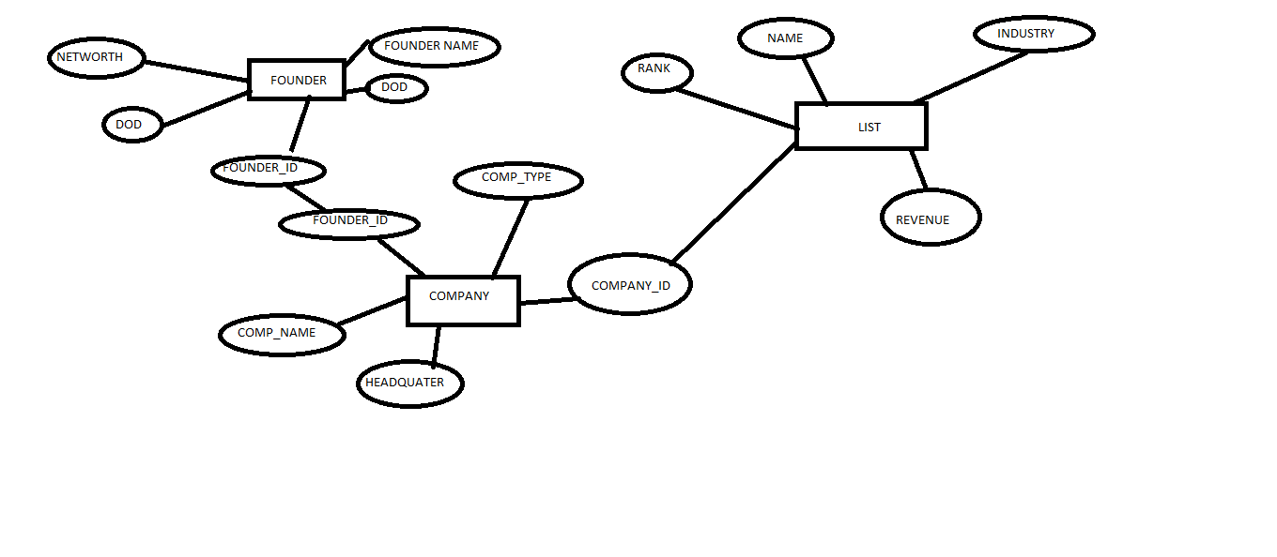

**5.DATA TABLES**

**LIST**

|  |  |  |  |
| --- | --- | --- | --- |
| S.No. | Field Name | Data Type | Description |
| 1 | RANK | int | Store the rank of company |
| 2 | NAME | Varchar | Store the name of company |
| 3 | INDUSTRY | char | Store the type of industry(private/nonprivate) |
| 4 | REVENUE | int | Store the total revenue |
| 5 | COMP_ID | int | Store the company id |

**COMPANY**

|  |  |  |  |
| --- | --- | --- | --- |
| S.No. | Field Name | Data Type | Description |
| 1 | COMPANY_ID | int | Store the company id |
| 2 | NAME | varchar | Store the name of company |
| 3 | FOUNDER_ID | int | Store the founder id |
| 4 | TYPE | varchar | Store the type of company |
| 5 | HEADQUATER | varchar | Store the address of company |

**FOUNDER**

|  |  |  |  |
| --- | --- | --- | --- |
| S.No. | Field Name | Data Type | Description |
| 1 | FOUDER_ID | int | Store the founder_id |
| 2 | FOUNDER_NAME | varchar | Store the name of founder |
| 3 | DOB | date | Store the date of birth |
| 4 | DOD | date | Store the date of death |
| 5 | NETWORTH | int | Store the networth |

**SOURCE CODES:**

**update:**

**private void jButton1ActionPerformed(java.awt.event.ActionEvent evt) {**

**// TODO add your handling code here:**

**try{**

**Class.forName("oracle.jdbc.OracleDriver");**

**//step2 create the connection object5**

**int pidd=Integer.parseInt(pid.getText());**

**String pnamee=(pname.getText());**

**String typee= (type.getText());**

**int qtyy=Integer.parseInt(qty.getText());**

**String weightt= (weight.getText());**

**Connection con = DriverManager.getConnection(**

**"jdbc:oracle:thin:@Amit:1521:xe","system","amit");**

**Statement stmt=con.createStatement();**

**stmt.executeUpdate("insert into product_info values('"+pidd+"','"+pnamee+"','"+typee+"','"+qtyy+"','"+weightt+"')");**

**JOptionPane.showMessageDialog(null,"Inserted Successfully!");**

**pid.setText("");**

**pname.setText("");**

**type.setText("");**

**qty.setText("");**

**weight.setText("");**

**//step5 close the connection object**

**stmt.close();**

**con.close();**

**}catch( ClassNotFoundException | SQLException e){ System.out.println(e);}**

**}**

**VIEW:**

**private void jButton2ActionPerformed(java.awt.event.ActionEvent evt) {**

**// TODO add your handling code here:Class.forName("oracle.jdbc.Driver.OracleDriver");**

**//step2 create the connection object5**

**try{**

**Class.forName("oracle.jdbc.OracleDriver");**

**try (//step2 create the connection object**

**Connection con = DriverManager.getConnection(**

**"jdbc:oracle:thin:@Amit:1521:xe","system","amit")) {**

**String sql = "SELECT * FROM product_info";**

**Statement stmt=con.createStatement();**

**stmt = con.createStatement();**

**ResultSet rs = stmt.executeQuery(sql);**

**//STEP 5: Extract data from result set**

**table.setModel(DbUtils.resultSetToTableModel(rs));**

**rs.close();**

**}**

**//step5 close the connection object**

**}catch( ClassNotFoundException | SQLException e){ System.out.println(e);}**

**}**

**DELETE:**

**private void jButton4ActionPerformed(java.awt.event.ActionEvent evt) {**

**// TODO add your handling code here:**

**try{**

**Class.forName("oracle.jdbc.driver.OracleDriver");**

**int id=Integer.parseInt(pid.getText());**

**try (//step2 create the connection object**

**Connection con = DriverManager.getConnection(**

**"jdbc:oracle:thin:@Amit:1521:xe","system","amit")) {**

**Statement stmt=con.createStatement();**

**stmt = con.createStatement();**

**String sql = "DELETE FROM product_info " +**

**"WHERE pid = ('"+id+"')";**

**stmt.executeUpdate(sql);**

**JOptionPane.showMessageDialog(null,"Deleted Successfully!");**

**pid.setText("");**

**//step5 close the connection object**

**}**

**}catch( ClassNotFoundException | SQLException e){ System.out.println(e);}**

**}**

**CHECK:**

**private void jButton1ActionPerformed(java.awt.event.ActionEvent evt) {**

**// TODO add your handling code here:**

**if(item.getSelectedIndex() == -1){**

**item.removeAllItems();**

**String id,type;**

**try{**

**Class.forName("oracle.jdbc.driver.OracleDriver");**

**try (//step2 create the connection object**

**Connection con = DriverManager.getConnection(**

**"jdbc:oracle:thin:@Amit:1521:xe","system","amit")) {**

**Statement stmt=con.createStatement();**

**stmt = con.createStatement();**

**String sql = "SELECT * FROM product_info";**

**ResultSet rs = stmt.executeQuery(sql);**

**//STEP 5: Extract data from result set**

**while(rs.next()){**

**//Retrieve by column name**

**id = (rs.getString("pid"));**

**item.addItem(id);**

**}**

**rs.close();**

**}**

**}**

**catch( ClassNotFoundException | SQLException e){ System.out.println(e);}}**

**}**

**6.SNAP SHOTS**

**Home page:**

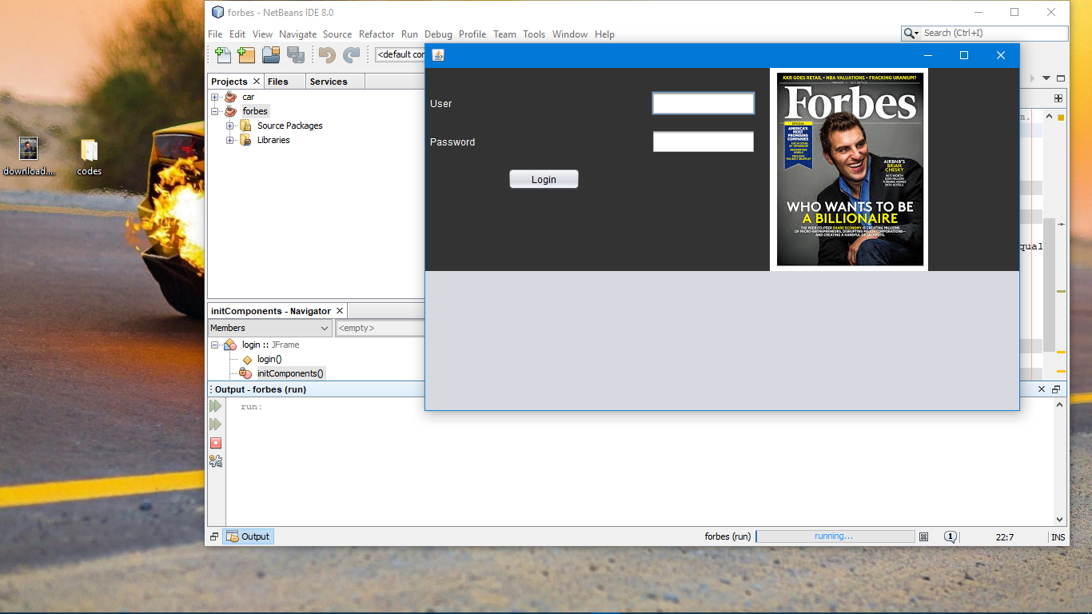

The login page has user id and password that can be access by the admin only. Once the id and password will be verified then we can logging successfully and admin can perform different operations.

**Invalid username or paasword:**

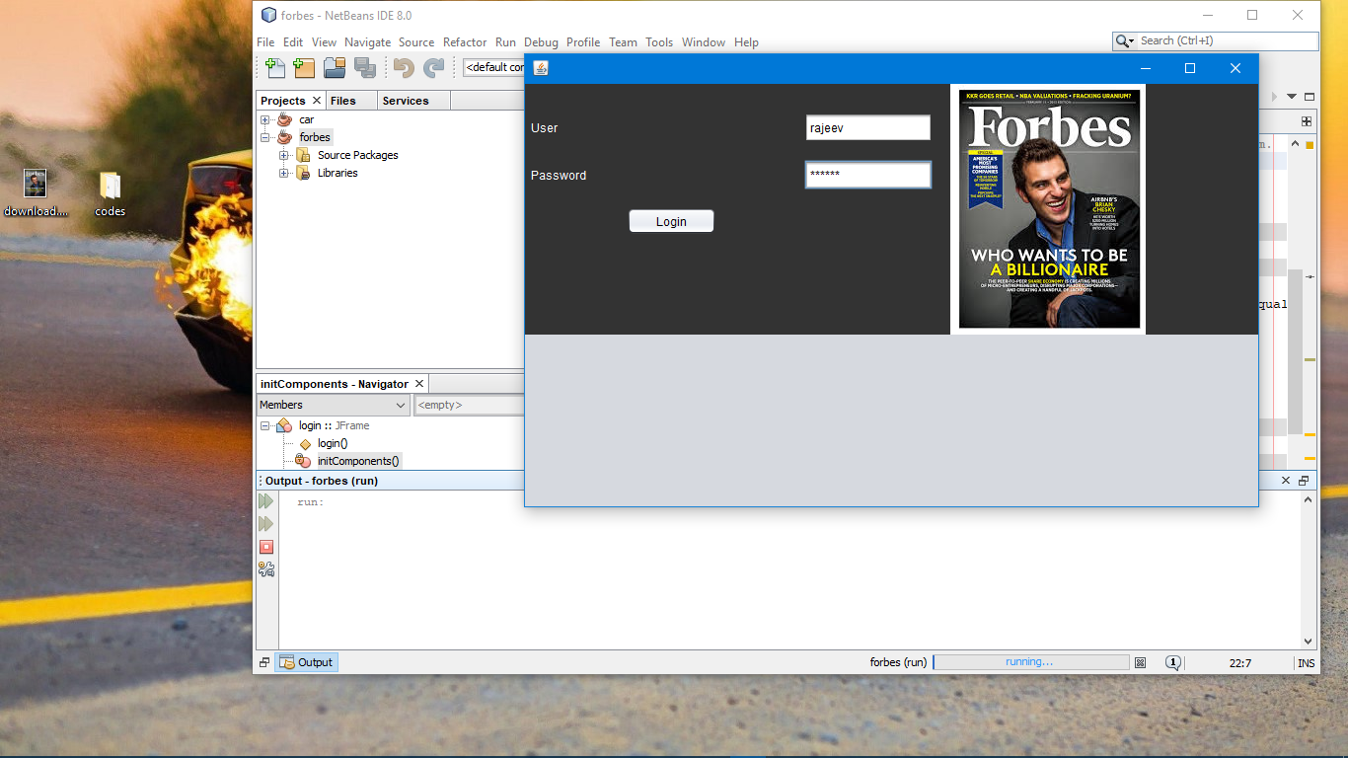

When admin enters wrong username or password. To re enter admin needs to re-enter the user_id and enter password details.

**Admin Login successful :**

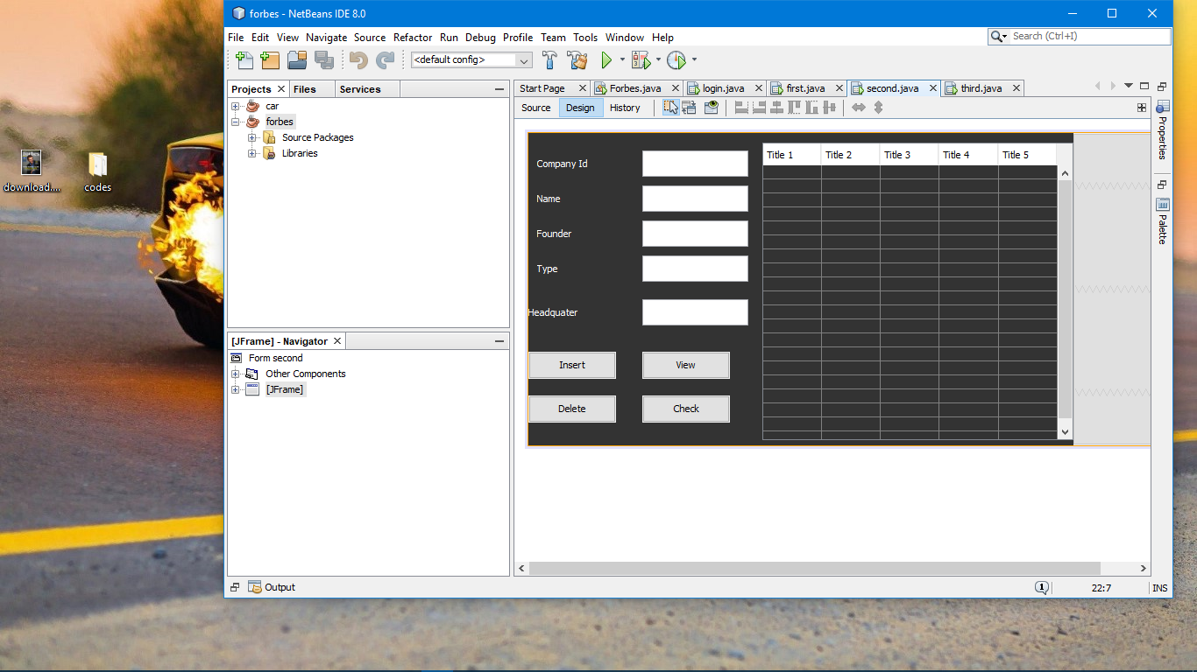

After admin has logged in successfully, he will get different options like founder information, founder_id,founder_name,dob,dod,and networth. To logout admin has to exit the window.

**founder info:**

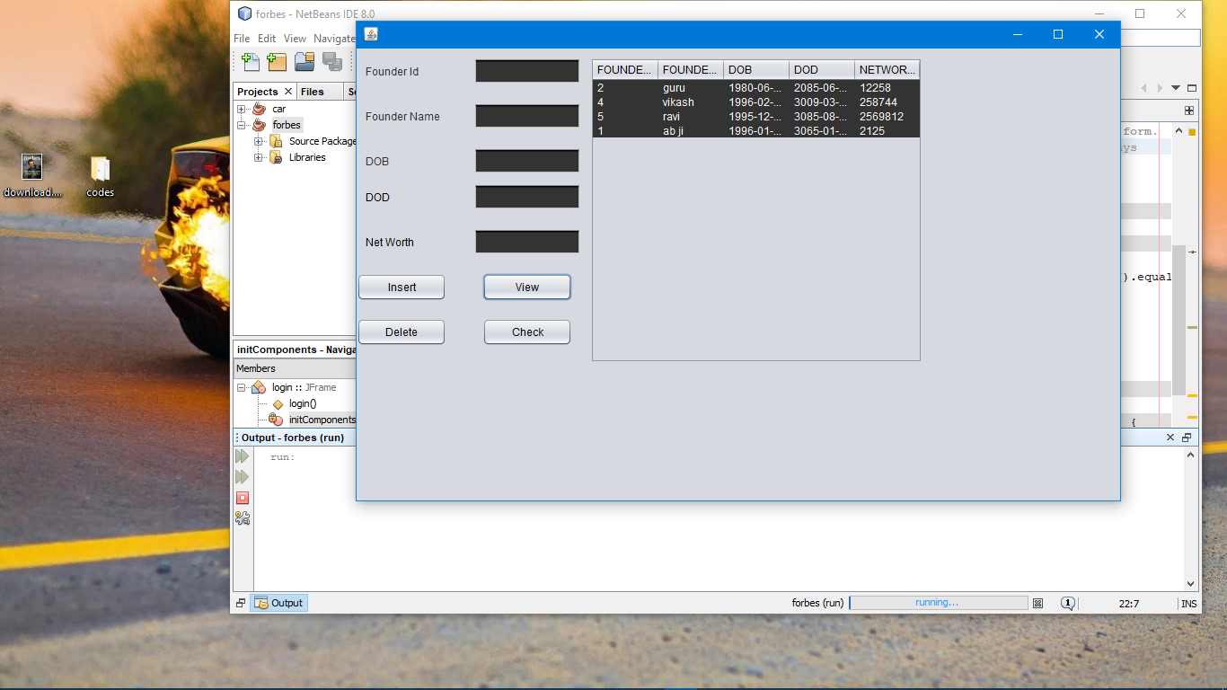

When admin clicks on view button he will get all the information about the founder info.

If there is new order,then new details like founder ID, founder name, dob, dod and networth can be filled according to order details and can be saved in database using insert button. After successful insertion a message will be displayed saying ‘Inserted successfully’.

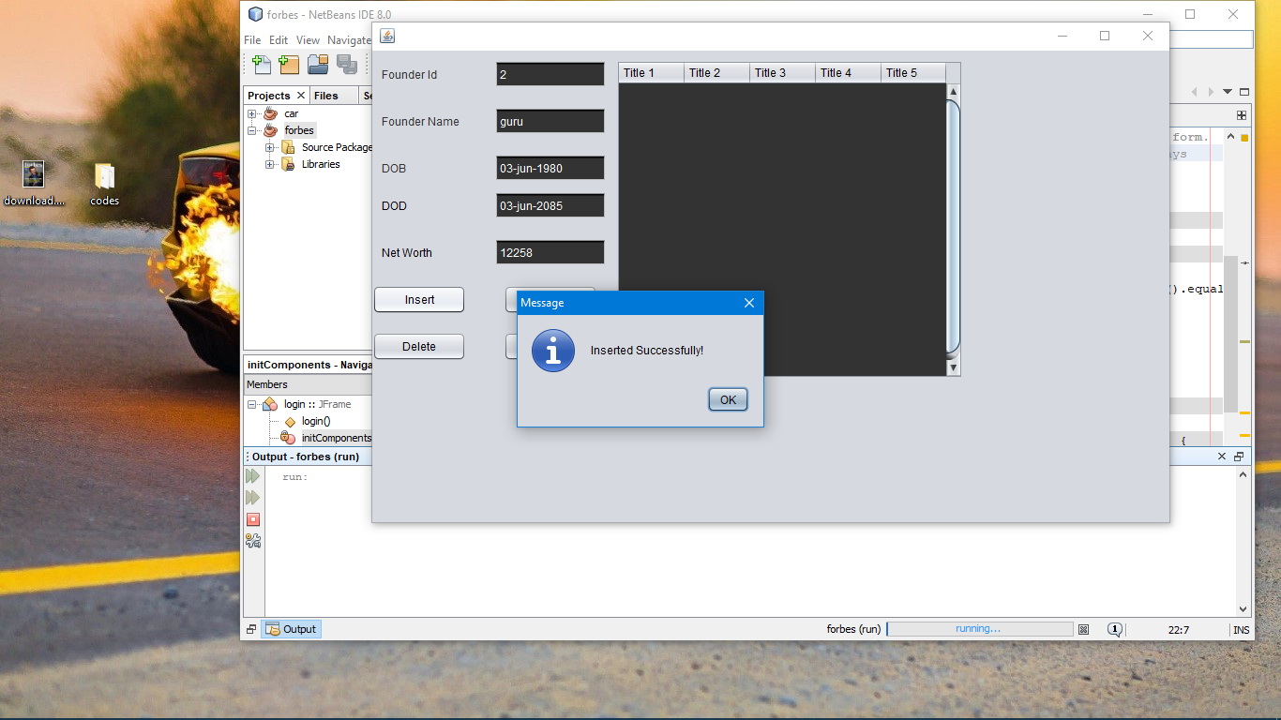

If an order detail has to be deleted from the database then it can be done by using delete button. Admin has to enter product id into product id box and then click on delete button. After successful deletion a message will be displayed displaying ‘Deleted successful’. To go back to the option form admin need to click on back button.

Before deleting



After deleting

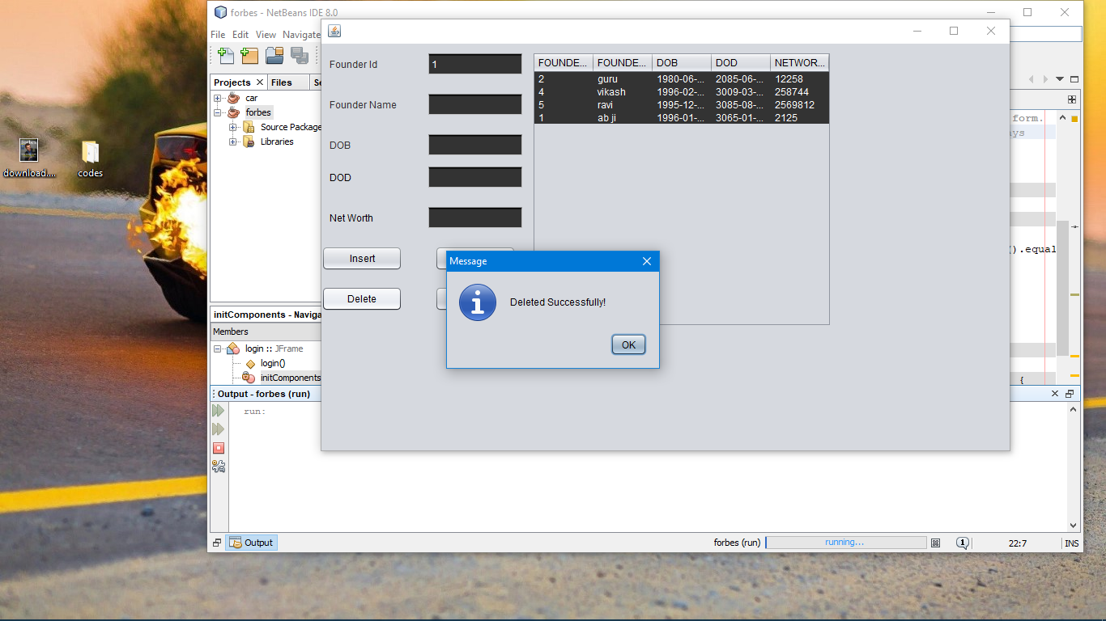

**Founder details form:**

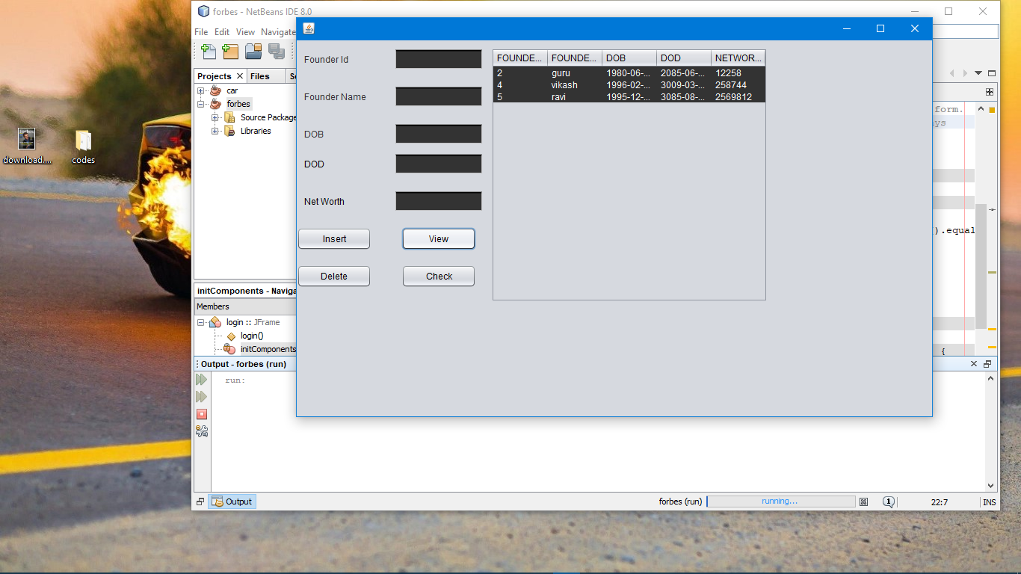

In delivery details form, admin gets all the details of the product which is to be delivered . Details like Customer name, Delivery date, Address and Phone number of the customer can be viewed and inserted using view and delete button. To go back to option page back button can be used.

**Founder details form :**



In founder details form admin gets all the details of the founder which is to be picked up . Details like founder name, founder dob date, Address and revenues of the founder can be viewed and inserted using view and delete button. To go back to option page back button can be used.

**Company Details:**



In this form admin can update the current location the company. The admin can update details like where the company_id, name of company, founder of company, type, and headquters. Admin needs to enter all these details in the required field and click insert button. After the successful insertion a message will be displayed saying ‘Inserted sucessfully’.

Updating the current details:





**Company rank details:**

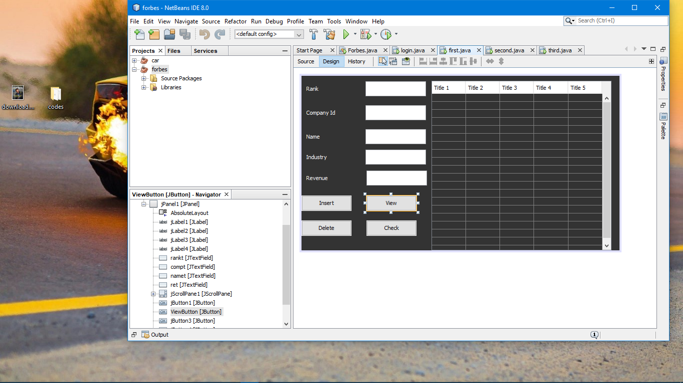

The company rank details shows the rank, company_id, name, industry(like IT or other), revenues.The insert button helps to insert the new upated details,view will shows the data has inserted earlier, delete will help in deleting the old data.

**CONCLUSION**

The Project “FORBES INFORMATION” is designed in order reduce the burden of company to maintain their database manually .It help the company to maintain their database in a systematic manner . Maintaining the project is also easy which can easily understandable. Maintaining the details in the database is manageable.

The concepts used in the development of this application is of my own, but certain referrals were made to my lecturers and friends regarding some technical issue.

This project has given us a wide knowledge of DBMS and JAVA and also help me in better understanding of concepts .

**Reference Book**

Java Complete Reference

<https://docs.oracle.com/javase/7/docs/api/javax/swing/package-summary.html>

<https://www.udemy.com/java-swing-complet>

<https://netbeans.org/kb/docs/java/quickstart-gui.html>

[**"Forbes sold to Asian investors"**](http://www.marketwatch.com/story/forbes-sold-to-asian-investors-2014-07-19)**.**